CS 3332 – PROJECT (Homework 7-12)
GROUP X
Members:
No. | Student Name | Student ID
1
2
3
4
5

We removed the programming exercise sections since they’re not required.

Assignment for Lecture 7-8:

Exercise 3.4
Extreme programming expresses user requirements as stories, with each story written on a card. Discuss the advantages and disadvantages of this approach to requirements of description.
STUDENT:
SOLUTION: | Advantages:  - User stories are simple, easy to understand, and can be read by both users and developers.  - They focus on what the user needs rather than technical implementation details.  - They are flexible and can be changed easily when requirements change.  - They support incremental development because the team can implement and test one story at a time.  Disadvantages:  - User stories may not include enough detail about constraints, exceptions, or non-functional requirements such as security, performance, and reliability.  - They depend heavily on direct communication with the customer, so misunderstandings can happen if the customer is unavailable.  - For large, complex, or safety-critical systems, story cards alone may not provide enough documentation, traceability, or formal approval.

Exercise 3.8
You are a software manager in a company that develops critical control software for aircraft. You are responsible for the development of a software design support system that supports the translation of software requirements to a formal software specification. Comment on the advantages and disadvantages of the following development strategies:
a. Collect requirements from software engineers and external stakeholders and develop the system using a plan-driven approach.
b. Develop a prototype using a scripting language, evaluate it with stakeholders, then redevelop the final system using Java.
c. Develop the system in Java using an agile approach with a user involved in the development team.
STUDENT:
SOLUTION: | a.  Advantages: This approach is suitable because aircraft-related software needs clear requirements, documents, reviews, and traceability. It helps the team check the system carefully before implementation.  Disadvantages: The weakness is that it is slow and not very flexible. If requirements change later, it may cost a lot to update the plan and documents.  b.  Advantages: This approach helps the team understand the requirements better. stakeholders can try the prototype and give feedback early. Then the final Java system can be built more correctly.  Disadvantages: The system is almost built twice, so it takes more time and money. Also, stakeholders may think the prototype is already the real system. The prototype should be thrown away only.  c.  Advantages: Agile development gives continuous user feedback and allows the team to adjust requirements during development. It also delivers working software in small increments and avoids building the system twice.  Disadvantages: Agile methods may not naturally produce enough documentation, traceability, and certification evidence. One user may also not represent all stakeholders.

Exercise 3.9
Exercise 3.9 of Pressman (p93): Write an XP user story that describes the “favorite places” or “bookmarks” feature available on most Web browsers.
STUDENT:
SOLUTION: | An XP user story for the “favorite places” or “bookmarks” feature could be:  - If users want to save the current web page as a bookmark, they can easily return to that page later without typing the URL again or searching for it.  - The browser should let users click the bookmark button while they are viewing a page. It should save the page title and web address. Later, users should be able to open their bookmark list and select that saved page. They should also be able to rename the bookmark, organize it into a folder, and delete it when they do not need it anymore.

Course Project
Begin to write the Software Requirement Specification document of your project.
STUDENT:
SOLUTION:

Assignment for Lecture 10:

Exercise 5.3
You have been asked to develop a system that will help with planning large-scale events and parties such as weddings, graduation celebrations, birthday parties, etc. Using an activity diagram, model the process context for such a system that shows the activities involved in planning a party (booking a venue, organizing invitations, etc.) and the system elements that may be used at each stage.
STUDENT:
SOLUTION: | 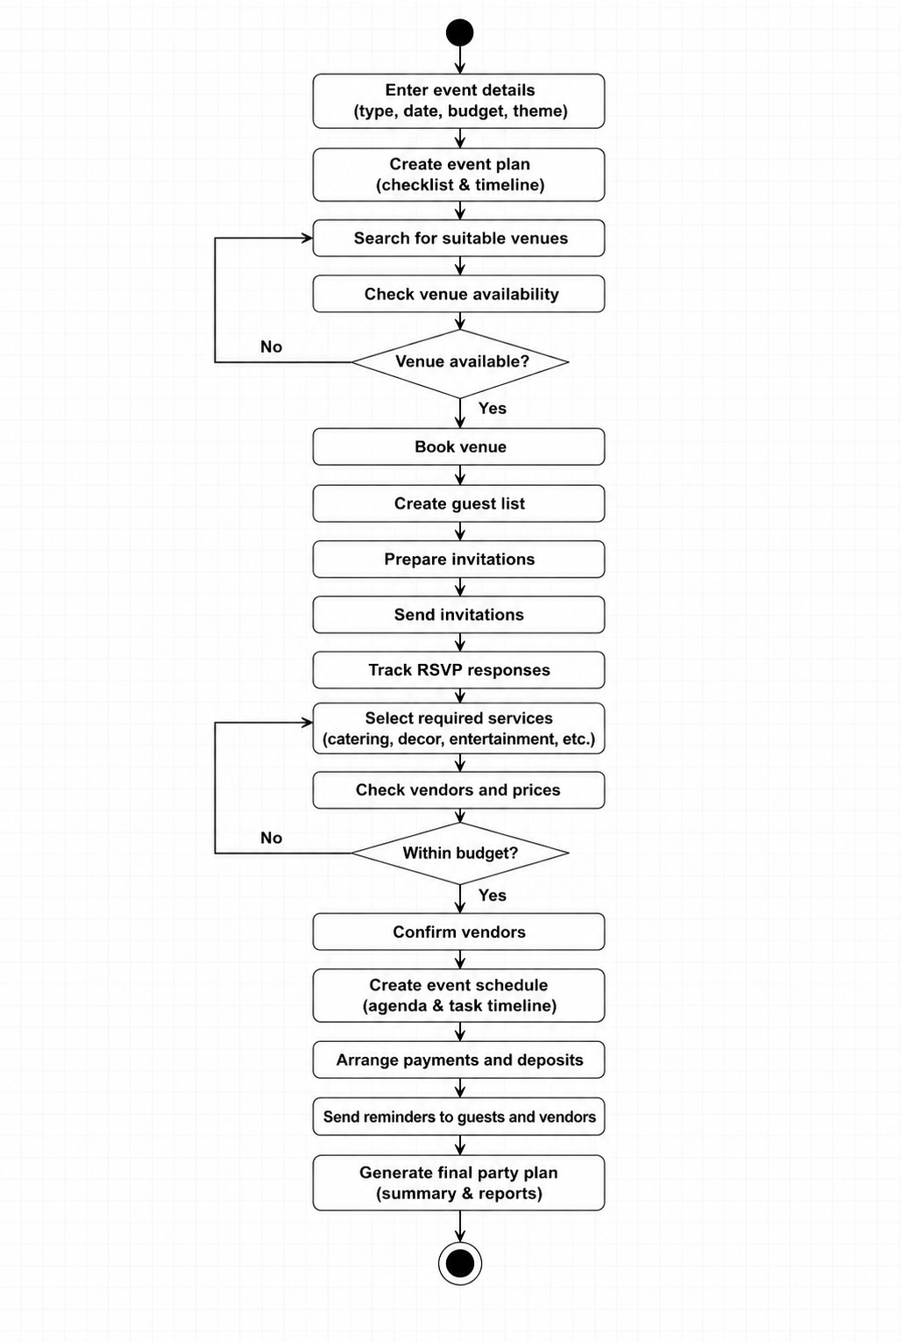

Exercise 5.4
For the MHC-PMS, propose a set of use cases that illustrates the interactions between a doctor and the MHC-PMS.
STUDENT:
SOLUTION: | - The main actor is the doctor. The MHC-PMS is used to support the doctor when seeing patients, recording medical information, and prescribing medicine or treatment.  Use case Description  Search patient record The doctor searches for a patient with a patient’s ID, name, or appointment information.  View medical history The doctor views previous consultations, diagnoses, treatments, and medication history.  Record consultation The doctor records symptoms, observations, diagnosis, and notes from the consultation.  Prescribe medication The doctor selects medicine, frequency, and duration. The system stores the prescription.  Recommend treatment The doctor records treatment plans, follow-up instructions.  Check warnings The system warns the doctor about allergies, unsafe medicine combinations, or incomplete patient data.  Update patient condition The doctor updates the patient’s current condition after examination or treatment.  Generate report The system produces a printable or electronic prescription, treatment summary.  - These use cases show that the system supports both information retrieval and information update. The doctor depends on the system to access reliable patient information and to store new medical decisions.

Exercise 5.9
Draw state diagrams of the control software for:
■ An automatic washing machine that has different programs for different types of clothes.
■ The software for a DVD player.
■ A telephone answering system that records incoming messages and displays the number of accepted messages on an LED. The system should allow the telephone customer to dial in from any location, type a sequence of numbers (identified as tones), and play any recorded messages.
STUDENT:
SOLUTION: | - An automatic washing machine that has different programs for different types of clothes.  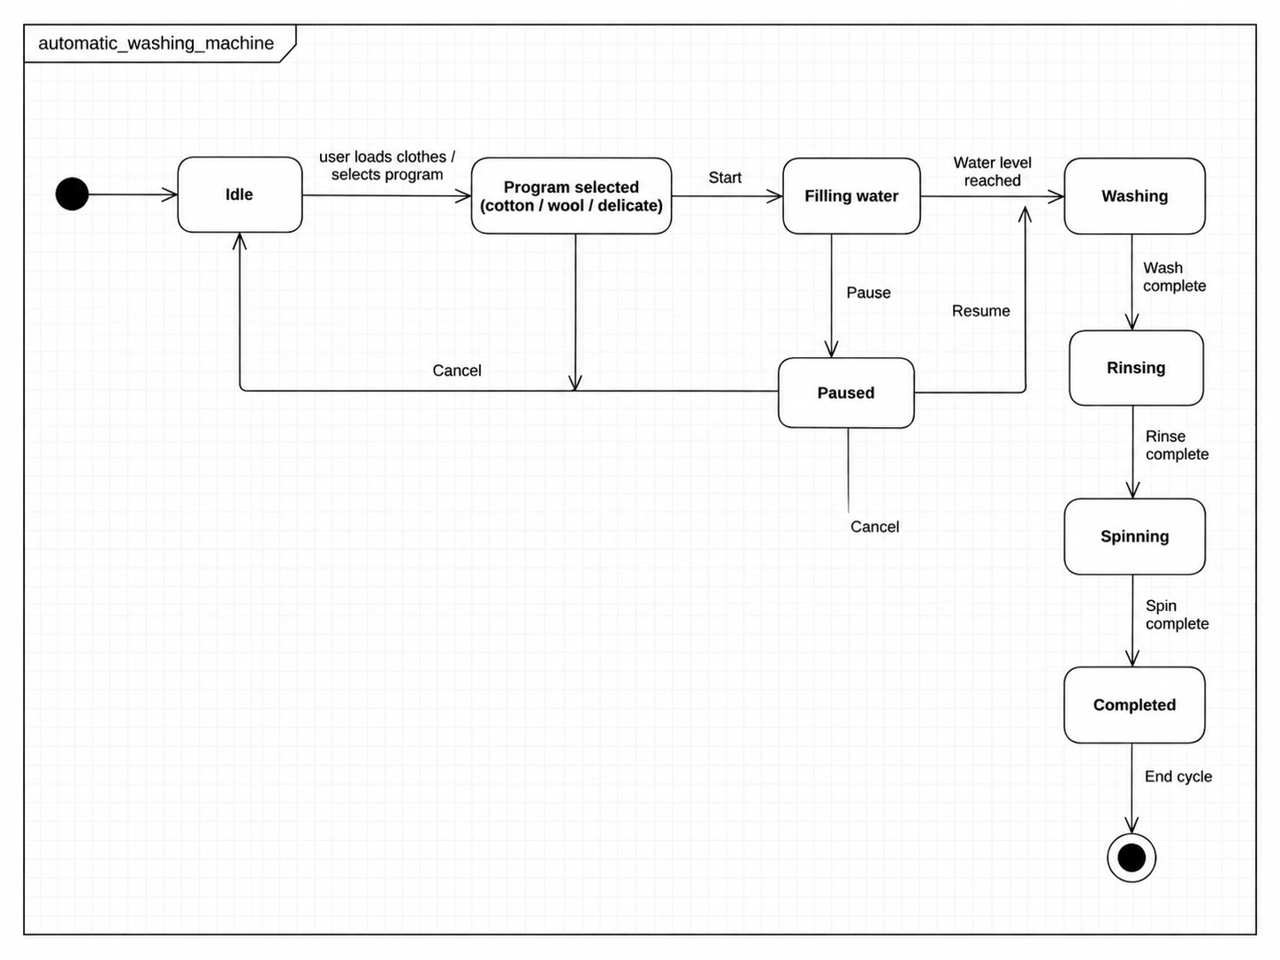  - The software for a DVD player.  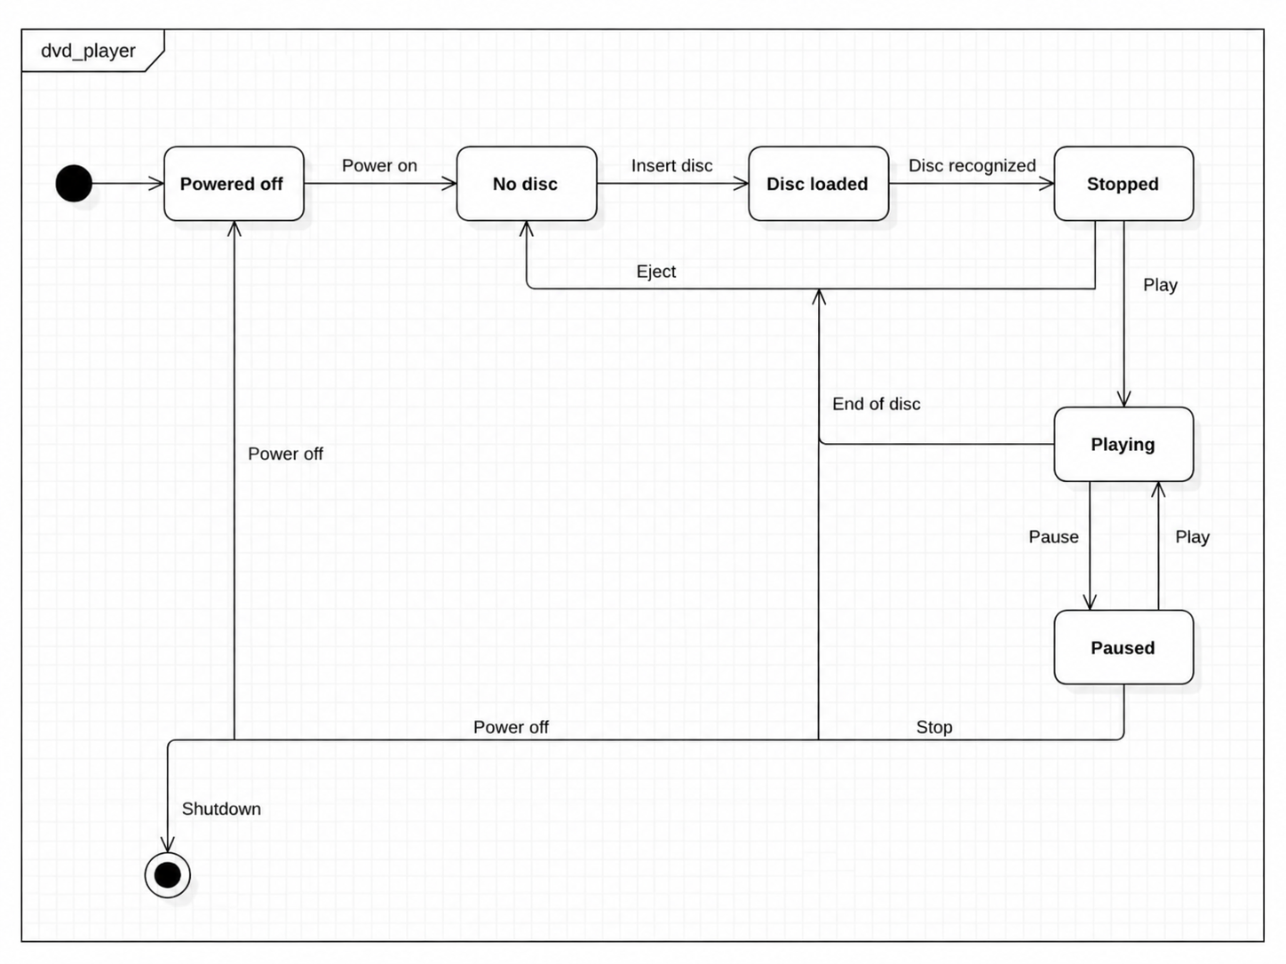  - A telephone answering system that records incoming messages and displays the number of accepted messages on an LED.  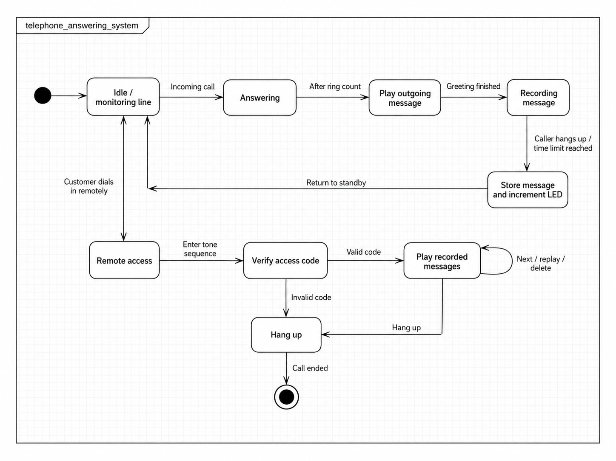

Course Project
Complete the Software Requirement Specification with Use case diagram, Use case Description and Activity diagram or Sequence diagram if necessary.
STUDENT:
SOLUTION:

Assignment for Lecture 11:

Exercise 6.1
When describing a system, explain why you may have to design the system architecture before the requirements specification is complete.
STUDENT:
SOLUTION: | A system architecture may need to be designed before the requirements specification is complete because the architecture helps the team understand the system more clearly. In many projects, stakeholders may not know all requirements at the beginning. When the team creates an early architecture, they can see the main components, interfaces, data flows, and external systems. This can help discover missing or unclear requirements.  Early architecture is also important for checking non-functional requirements. Requirements such as performance, security, and reliability often depend on architectural decisions. For example, if the system have to support many users, the team may need to decide early whether to use a client-server, layered, or distributed architecture.  Architecture can also show major technical risks and constraints, such as reusable components, legacy systems, databases, or communication protocols. Therefore, this early architecture should not be fixed too soon. It should be reviewed and changed when the requirements become clearer.

Exercise 6.3
Explain why design conflicts might arise when designing an architecture for which both availability and security requirements are the most important non-functional requirements.
STUDENT:
SOLUTION: | Design conflicts might arise because availability and security often push the architecture in different directions. High availability usually requires redundant servers, replication, and backup communication paths. These make the system more available, but they also increase the attack surface because there are more components, interfaces, and network connections to protect.  Security usually needs authentication, authorization, and strict access control. These controls can add delay and may reduce availability if they fail. For example, if the authentication server is very secure but not replicated, it can become a single point of failure. If it goes down, users cannot access the system even if the main service is still running.  There can also be conflict during maintenance. Security patches may require restarting or updating services, but availability requirements may demand continuous operation. Therefore, the architecture must balance both qualities by using careful access control and planned update mechanisms.

Exercise 6.4
Draw diagrams showing a conceptual view and a process view of the architectures of the following systems:
An automated ticket-issuing system used by passengers at a railway station.
A computer-controlled video conferencing system that allows video, audio, and computer data to be visible to several participants at the same time.
A robot floor cleaner that is intended to clean relatively clear spaces such as corridors. The cleaner must be able to sense walls and other obstructions.
STUDENT:
SOLUTION: | - An automated ticket-issuing system used by passengers at a railway station.  - Conceptual view  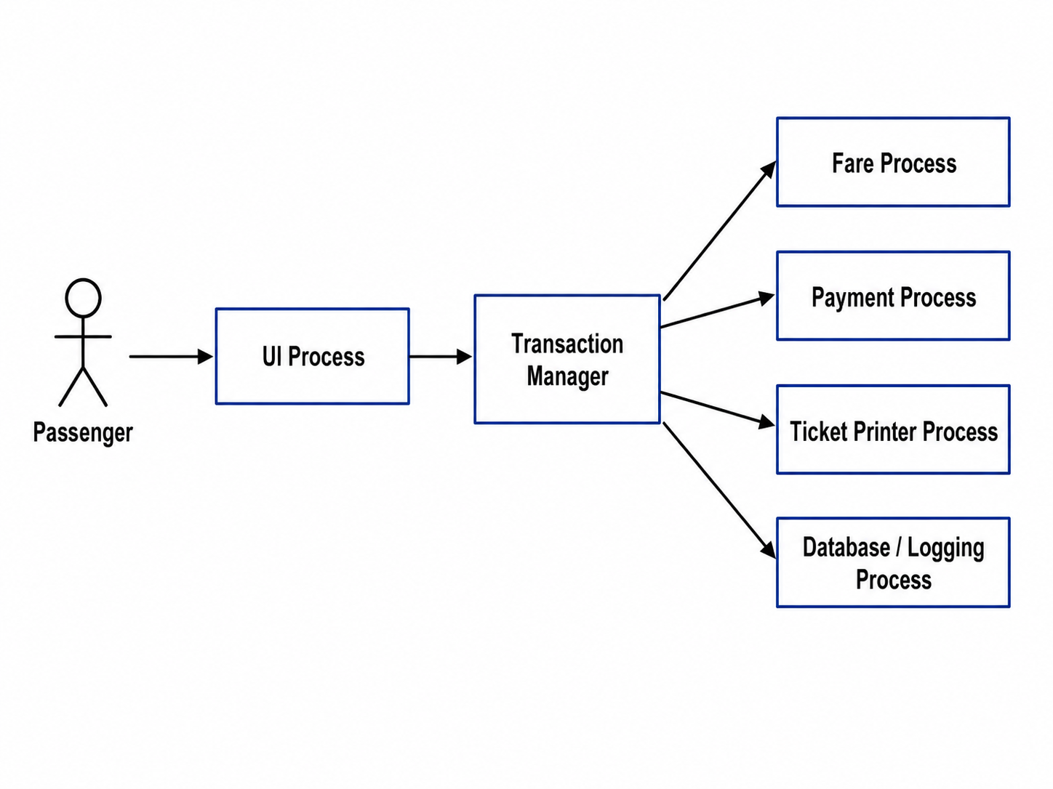  - Process view  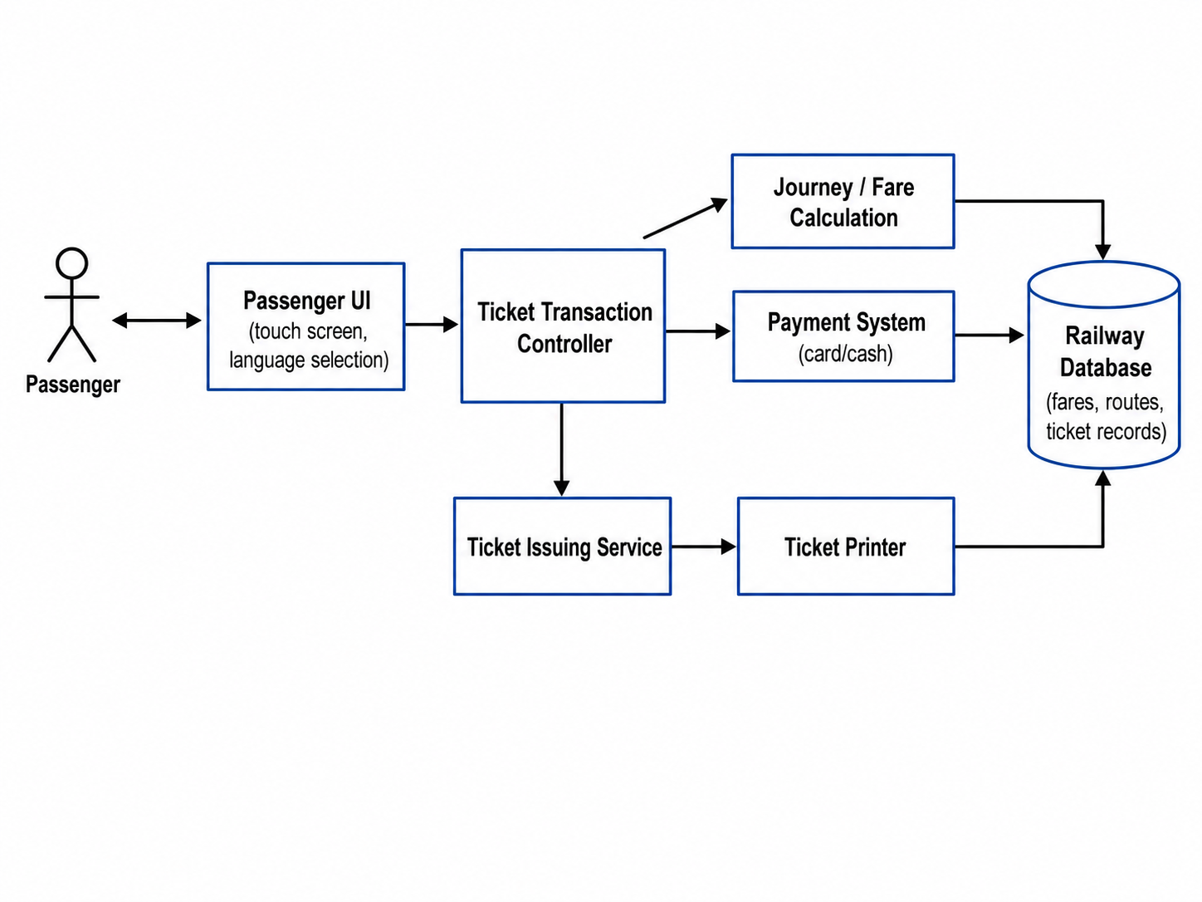  - A computer-controlled video conferencing system.  - Conceptual view  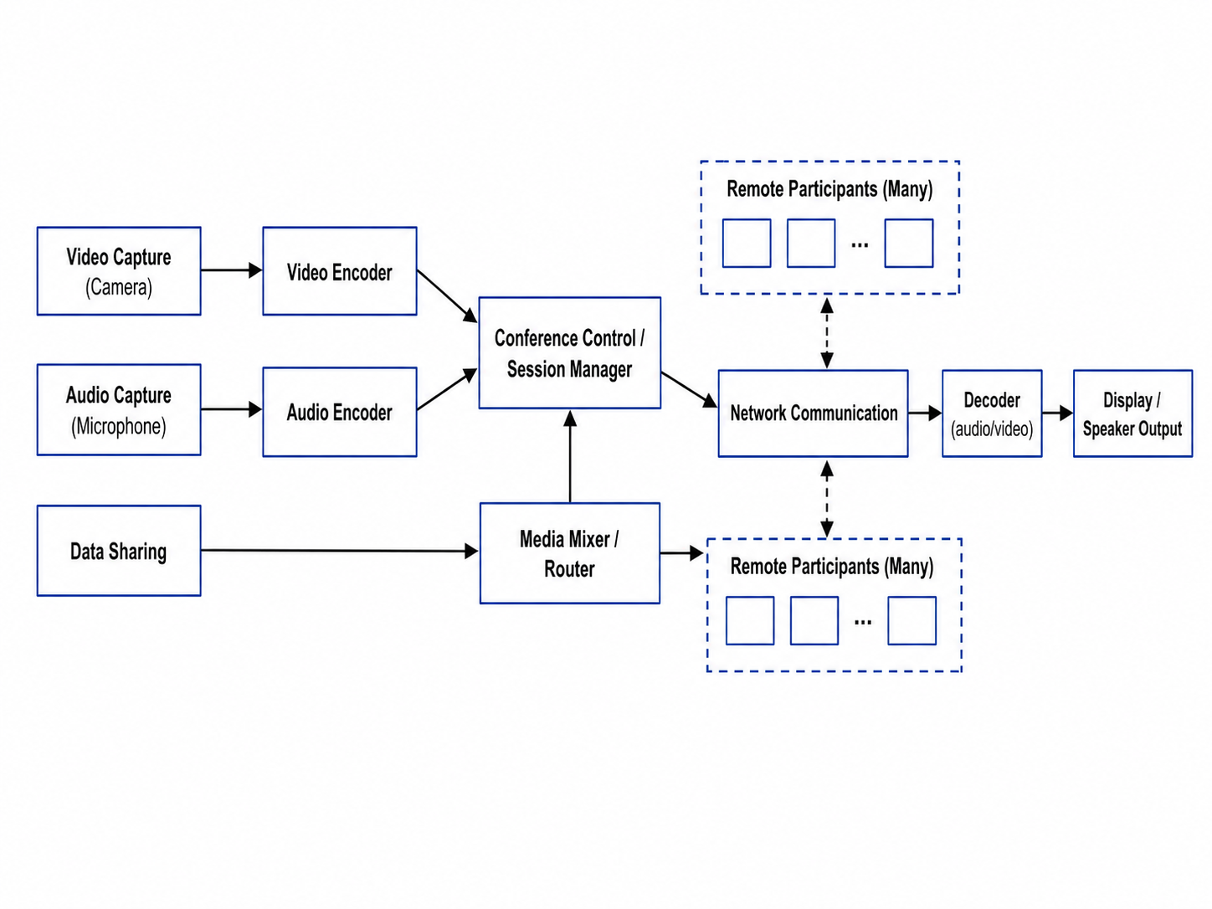  - Process view  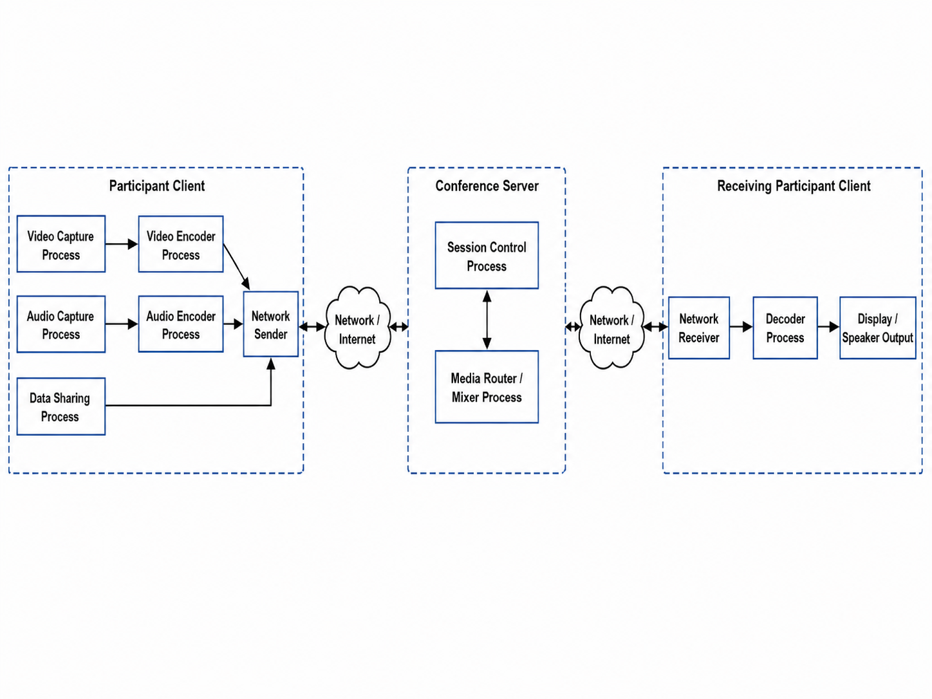  - A robot floor cleaner that is intended to clean relatively clear spaces.  - Conceptual view  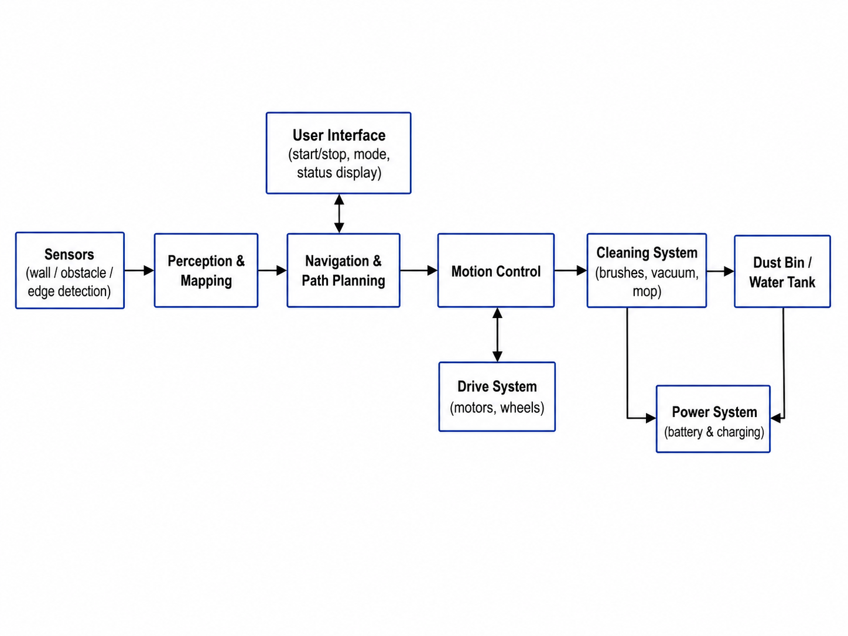  - Process view  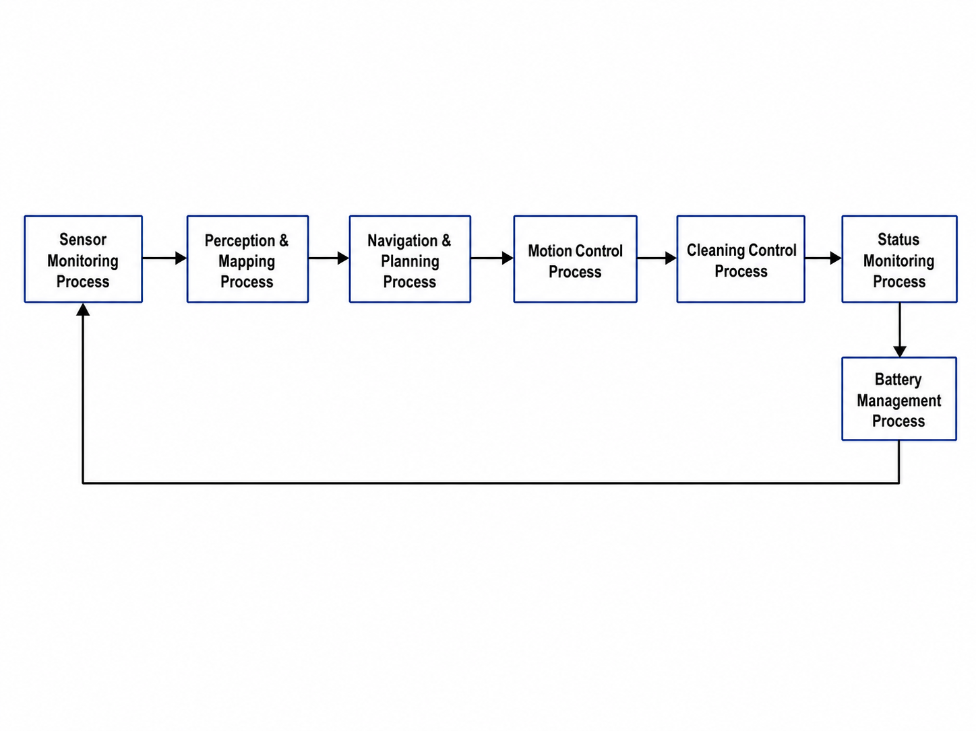

Course Project
Design the architecture of your system using Box-arrow notation.
STUDENT:
SOLUTION:

Assignment for Lecture 12: Using Junit

Exercise
Given a Date class with the following methods:
  - public Date(int year, int month, int day)
  - public Date()
  - public int getDay(), getMonth(), getYear()
  - public void addDays(int days) // advances by days
  - public int daysInMonth()
  - public String dayOfWeek() // e.g. "Sunday"
  - public boolean equals(Object o)
  - public boolean isLeapYear()
  - public void nextDay() // advances by 1 day
  - public String toString()
- Come up with unit tests to check the following:
- That no Date object can ever get into an invalid state.
- That the addDays method works properly.
It should be efficient enough to add 1,000,000 days in a call.
STUDENT:
SOLUTION: | The unit tests should focus on both correctness and robustness. A Date object should never represent an impossible date such as month 13, day 0, February 30, or April 31. The addDays method should correctly move across days, months, years, and leap years, and it should also be efficient for a very large number of days.  Test cases  Test group Example tests Expected result  Constructor validity new Date(2026, 1, 1), new Date(2024, 2, 29) Valid dates are created successfully.  Invalid month new Date(2026, 0, 10), new Date(2026, 13, 10) The constructor rejects the value or prevents an invalid state.  Invalid day new Date(2026, 4, 31), new Date(2026, 2, 30) The constructor rejects invalid calendar dates.  Leap year new Date(2024, 2, 29) and new Date(2025, 2, 29) Leap-year February 29 is valid; non-leap-year February 29 is invalid.  nextDay 2026-01-31.nextDay() The date becomes 2026-02-01.  addDays across month 2026-01-30.addDays(2) The date becomes 2026-02-01.  addDays across leap day 2024-02-28.addDays(1) The date becomes 2024-02-29.  addDays across year 2026-12-31.addDays(1) The date becomes 2027-01-01.  Large addDays 2026-01-01.addDays(1_000_000) The method finishes quickly and produces a valid date.  equals and toString Compare equal and different Date objects equals returns correct result and toString is consistent.  Sample JUnit 5 tests  import static org.junit.jupiter.api.Assertions.*;  import java.time.Duration;  import org.junit.jupiter.api.Test;  class DateTest {  @Test  void validDatesCanBeCreated() {  Date d1 = new Date(2026, 1, 1);  assertEquals(1, d1.getDay());  assertEquals(1, d1.getMonth());  assertEquals(2026, d1.getYear());  Date leap = new Date(2024, 2, 29);  assertEquals(29, leap.getDay());  }  @Test  void invalidDatesAreRejected() {  assertThrows(IllegalArgumentException.class, () -> new Date(2026, 0, 10));  assertThrows(IllegalArgumentException.class, () -> new Date(2026, 13, 10));  assertThrows(IllegalArgumentException.class, () -> new Date(2026, 4, 31));  assertThrows(IllegalArgumentException.class, () -> new Date(2025, 2, 29));  }  @Test  void nextDayCrossesMonthAndYear() {  Date d = new Date(2026, 1, 31);  d.nextDay();  assertEquals(new Date(2026, 2, 1), d);  Date y = new Date(2026, 12, 31);  y.nextDay();  assertEquals(new Date(2027, 1, 1), y);  }  @Test  void addDaysWorksAcrossMonthYearAndLeapYear() {  Date d = new Date(2026, 1, 30);  d.addDays(2);  assertEquals(new Date(2026, 2, 1), d);  Date leap = new Date(2024, 2, 28);  leap.addDays(1);  assertEquals(new Date(2024, 2, 29), leap);  }  @Test  void addOneMillionDaysIsEfficientAndValid() {  Date d = new Date(2026, 1, 1);  assertTimeout(Duration.ofMillis(200), () -> d.addDays(1_000_000));  assertTrue(d.getMonth() >= 1 && d.getMonth() <= 12);  assertTrue(d.getDay() >= 1 && d.getDay() <= d.daysInMonth());  }  }  If the Date class uses another policy for invalid dates, such as correcting invalid input instead of throwing IllegalArgumentException, the expected results should be adjusted. However, the important requirement is the same: after construction or any method call, the object must remain in a valid calendar state.

Contribution Summary Table
Lecture | Exercise / Task | Topic | Contributor
Lecture 7-8 | Exercise 3.4 | User stories in XP
Lecture 7-8 | Exercise 3.8 | Development strategies for critical software
Lecture 7-8 | Exercise 3.9 | XP user story for browser bookmarks / favorite places
Lecture 7-8 | Course Project | Begin SRS document
Lecture 10 | Exercise 5.3 | Activity diagram for event planning system
Lecture 10 | Exercise 5.4 | MHC-PMS doctor use cases
Lecture 10 | Exercise 5.9 | State diagrams for control software
Lecture 10 | Course Project | Complete SRS with diagrams and use cases
Lecture 11 | Exercise 6.1 | Architecture before complete requirements
Lecture 11 | Exercise 6.3 | Availability and security design conflicts
Lecture 11 | Exercise 6.4 | Conceptual and process architecture views
Lecture 11 | Course Project | Box-arrow system architecture
Lecture 12 | Exercise | JUnit tests for Date class

